## Hutchins Center Fiscal Impact Measure: Projections Methodology

The Fiscal Impact Measure (FIM) is a gauge of the contribution of federal, state, and local fiscal policy to near-term changes in the gross domestic product, the tally of all the goods and services produced in the economy. It includes both the direct effects of government purchases as well as the more indirect effects of government taxes and government transfers. When FIM is positive, the government is contributing to real GDP growth, and when it is negative, it is subtracting from it.

We construct forecasts of fiscal policy’s contribution to GDP following the same methodology we use to construct the FIM itself. This document outlines how we construct our projections of the components of the FIM: Federal consumption and investment, state and local government consumption and investment, and taxes and transfers at all levels of government. These projections rely on the Congressional Budget Office’s (CBO) ten-year economic and budgetary projections.

### Major outstanding questions

* How can we make the state and local projection more robust? We assume essentially no variation in FI from state and local after 2021.
  + *Note*: State and local is projected to have a relatively large FI over the next two to three years, as CBO expects spending in this sector to increase and decrease with aggregate economic activity (as demand for state and local services and revenues at that level rise and fall with output). In CBO’s projections, the annual growth rate of real state and local purchases is 1.6 percent in 2018 and then declines—to 1.3 percent in 2019 and to 1.0 percent in 2020—before settling at 0.6 percent in 2024, roughly the rate of population growth.
* Changing assumptions about future law (discretionary spending, income taxes) means we can change our projections for those variables but it’s more complicated to change the baseline, i.e., the economic baseline projections (GDP and consumption) are endogenous to those variables, so will our projected measure of fiscal impact be inflated if we change the variable assumptions but not the macroeconomic assumptions?
  + In particular, CBO has already priced in the effects of TCJA in their GDP forecast. Does this matter for our measure of fiscal impact? They project that the tax act will increase the level of real GDP by 0.7 percent on average over the 2018-2028 period.
* In what format do we want to present the forecast? As an additional button on the same interactive?

## Government consumption and investment

To project the direct effects of government consumption and investment on GDP, we take projected government consumption and investment from CBO’s economic projections, which flow out of its budgetary projections and assumptions about future spend-out rates of allocated funds. Specifically, we project future levels of federal, state, and local current expenditures using today’s levels and projected growth rates.

[Should we talk to someone at CBO to confirm that these GDP component projections are tied to budgetary projections?]

Importantly, CBO’s projections assume that current law will remain in place over the projection horizon. We deviate from this assumption at two junctures that we describe in this document. The first is the assumption that current discretionary spending caps, which were raised by approximately $152 billion in the Bipartisan Budget Act of 2018, will expire and return to their set path under 2011 law at the end of 2019. In our baseline forecast, we assume these caps will remain in place (at a higher level than current law entails), and that discretionary spending will grow in line with CBO’s longer term budget projections beginning in fiscal 2019. As a result, our baseline forecast sees a more moderate decline in fiscal impact from federal spending over the projection period than does a projection that assumes current law will remain in place.

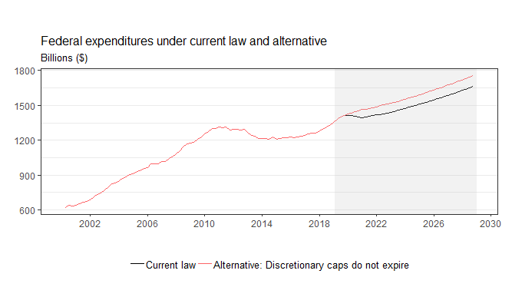

We then calculate the projected future fiscal impetus from federal spending as its share of nominal GDP times its projected real growth rate:

$$FIM_{t+h}^{Fed}=\frac{Fed_{t+h}}{GDP_{t+h}}*g_{t+h}^{Fed}$$

where $FIM_{t}^{Fed}$ is the contribution of federal expenditures to real annualized GDP growth, $Fed_{t}$ is nominal current federal expenditures, $GDP_{t}$ is GDP in current dollars, and $g_{t}^{Fed}$ is the real annualized growth rate of federal expenditures.

*Q: How do you project federal spending under the assumption that the existing discretionary spending caps will remain in place?*

A: Between the date of the spending caps’ expiration under current law and the date of spending growth’s return to its longer-term trend (which we take as implied from CBO’s projections), we assume that spending as a share of the economy follows its long-term trend, and declines by about 0.8 percentage point over a decade. Under current law, spending as a share of the economy declines more rapidly in the next five years, and by a total of 1.2 percentage points over the course of a decade. (Assuming that spending as a share of GDP follows its longer-run trend is approximate to assuming that spending growth follows its longer-term trend growth over that period, which is about 2½ percent annual growth).

[CBO’s economic projections of the components of GDP are not smooth. I don’t know why. But I speculate that it has something to do with matching budget projections on the fiscal year to calendar year current expenditures. To remedy this, I just calculate quarterly annualized growth rates and smooth them out over four quarters. I then use the smoothed growth rate to project levels.]

## State and local consumption and investment

Like the federal component, we use CBO’s quarterly economic projections to forecast future state and local expenditures based on today’s levels. [We don’t know how CBO projects this component, but think they just assume it will remain constant as a share of the economy at about 10 percent]. We then calculate the projected fiscal impact from state and local expenditures as

$$FIM_{t+h}^{SL}=\frac{{SL}_{t+h}}{GDP_{t+h}}*g_{t+h}^{SL}$$

where $FIM_{t}^{SL}$ is the contribution of federal expenditures to real annualized GDP growth, $Fed_{t}$ is nominal current federal expenditures, $GDP_{t}$ is GDP in current dollars, and $g_{t}^{SL}$ is the real annualized growth rate of state and local expenditures.

*Q: How do you account for changes in current law that may affect CBO’s estimates of discretionary federal grants to state and local governments?*

A: Total grants to state and local governments averaged around $580 billion in 2018, but about 70 percent of this is mandatory spending on health. Discretionary accounts that are affected are negligible.

*Q: How do you account for changes in legislation at the state and local level that would affect spending, taxes, and transfers?*

We don’t right now. Should we be thinking more seriously about this?

## Transfers and taxes

[CBO provides some estimates of federal current receipts and expenditures as they appear in the national accounts. However, these projections are based on the fiscal year. We take the implied annual growth rates from these projections, impute them to each of the four quarters to which the fiscal year applies (Q4 of previous calendar year through Q3 of current calendar year), and smooth them out over four quarters. This is my current method for translating annual level of current receipts and expenditures into smooth quarterly annualized growth rates of current receipts and expenditures.]

### Medicare and Medicaid

We assume spending on the major healthcare programs at all levels of government will grow in line with CBO’s projected growth for spending on these programs at the federal level.

*Q: Is there any reason to believe that total health spending will diverge from the federal appropriations?*

*A: If many states vote to expand Medicaid for the first time, this could impact both federal and state and local health spending. Otherwise, without major legislative changes to Medicaid the existing law (FMAP’s) imply that aggregate spending will grow with spending at the federal level.*

[It’s also possible that states could expand their own benefit programs but these would (a) probably be small and (b) this question falls into the broader question of how we plan to account for legislative changes at the S&L level.]

### Other government benefits

We assume spending on other benefit programs at the federal level will grow in line with CBO’s projections. At the state and local level, where benefit programs do not have mandatory budget allocations, we assume non-health benefits will grow in line with CBO’s projections for total current expenditures at the state and local level.

### Taxes

At the federal level, we assume all non-personal taxes will grow in line with CBO’s projections for these categories after the passage of the Tax Cuts and Jobs Act (TCJA) in 2017. Under this assumption, corporate taxes will continue to grow at a moderate pace (average 7 percent nominal), payroll taxes will grow at a slightly lower rate (4.7 percent nominal), and production and import taxes (which mostly reflect state and local taxes) will grow at a lower rate (3.8 percent nominal). Under current law, the income tax provisions of TCJA, which lowered the effective tax rate paid by individuals, expire in 2025. We assume, instead, that the lower effective rate will remain in place for individuals past 2025. As a result, our baseline projection foresees higher fiscal stimulus through 2025 than would a projection based on current law.

To incorporate this assumption, we assume that income taxes will grow at their longer-run rate (5.4 percent nominal) past 2025.

[With or without the assumption about the sunset provision, we see a significantly smaller impetus from the tax act than does CBO. They see a whole percentage point added to GDP over the course of 2022-2024. This could be due to investment, which we’re not capturing.]

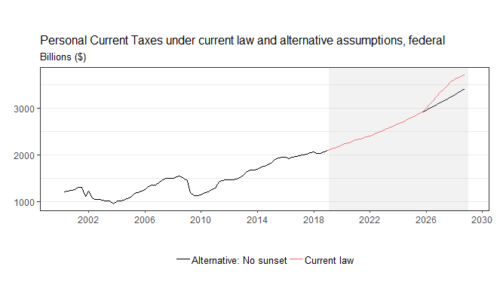

We then calculate the projected fiscal impact from state and local expenditures as

$$FIM_{t+h}^{τ}=\frac{τ_{t+h}}{GDP_{t+h}}*{(g}_{t+h}^{C}- g_{t+h}^{τ})$$

where $FIM_{t}^{τ}$ is the contribution of taxes and transfers to real annualized GDP growth, $τ_{t}$ is nominal consumption net of taxes and transfers, $g_{t}^{C}$ is the real annualized growth rate of personal consumption expenditures (PCE) and $g_{t}^{τ}$ is the real annualized growth rate of PCE net of transfers and taxes. $τ_{t}$ is calculated by subtracting from PCE the tax and transfer components times their respective marginal propensities to consume (MPCs), which we define in the methodology for the FIM.